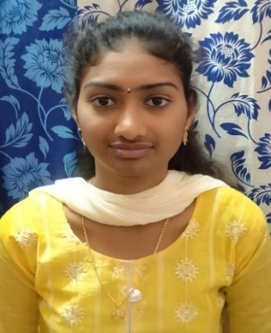**BAVIRISETTY GANGA BHAVANI**

E-MAIL : bavirisettyganga@gmail.com

MOBILE : +91 9182926980

**CAREER OBJECTIVE**

To obtain a promising career in an innovative organization where I can utilize



my capabilities and technical skills contribute consistently and significantly

to the organization.

**EDUCATIONAL QUALIFICATION**



|  |  |  |  |  |  |
| --- | --- | --- | --- | --- | --- |
| **Degree** | **Discipline/**  **Specialization** | **School/College** | **Board/**  **University** | **Year of Passing** | **CGPA** |
| B. Tech. | Electronics and Communication Engineering | Visvodaya Engineering  College | JNTU Anantapur | 2023 | **80.02%** |
| Intermediate | MPC | Sai co-operative junior  College | BIEAP | 2019 | **93%** |
| S. S. C | S.S.C | Jaya Usha Telugu medium  High School | S.S.C | 2017 | **95%** |

**TECHNICAL SKILLS**



* Basics of C and JAVA
* JAVA Full Stack
* Manual Testing
* Arduino Programming

**MINI-PROJECT**



**SMOKE DETECTOR**

Designed smoke detector by using Arduino Board and smoke sensor and few more components. It is the circuit which detects the smoke leakage in the surroundings .when it detects the smoke(o2 etc) automatically blinks the lights and activates the buzzer it also used to detect the fire accidents.

**MAJOR-PROJECT**



**BINARY COUNTERS GENERATED BY USING SORTING NETWORK (VLSI)**

In this project the counters counts the number of 1s present in the applied input gives output

in binary format. The existing system consists only full adders it takes large power and produces more

delay but in the proposed system by using sorting network we reduced the power and delay with out

any change in the functionality. These counters are used in Filters (Clock generation), Electronic devices and traffic measuring etc.

**ACHIEVMENTS**



* Completed an internship on **JAVA FULL STACK** conducted by **KODNEST** in 2K23
* Participated in **EMPLOYABILITY SKILL PROGRAMME** conducted by Mahindra Pride Classroom and Naandi Foundation in 2K23
* One of the organizersin the fest conducted by ECE department in Visvodaya Engineering College in 2k22
* Presented a paper on **BIO BATTERY** Organized by PBR VITS in 2k22
* Presented a paper on **SENSORS** Organized by Narayana Engineering College in 2k21
* Attended in **ARDUINO PROGRAMING** conducted by Visvodaya Engineering College in 2K21
* Presented a paper on **BJT** (Bi-polar junction transistor) by Geethanjali Institutions in 2K21
* Actively participated in various programs in school Level got many appreciations

**PERSONALITY TRAITS**



* Hard worker, Fast learner and can complete work in stipulated time
* Have Leadership skills and always with smiling face and activeness
* Punctual and flexible during work hours.
* Able to mingle with others easily

**PERSONAL PROFILE**



Date of Birth : 02-02-2002

Father name : Bavirisetty Siva Satyanarayana

Hobbies : Internet Browsing , Playing shuttle , Paper craft , Pencil Sketch

Address : 10-49-59/A

Balaji street

Kavali (524201)

Nellore (dist.)

**DECLARATION**I hereby declare that the above-mentioned information is correct up to my knowledge and I bear the responsibility for the correctness of the above-mentioned particulars.



Place**:**  ( Bavirisetty GangaBhavani)

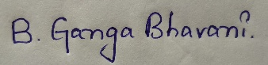Date: